Customer Analytics

Oliver J. Rutz

**Exercise 2 – Market Structure Analysis for a Game App**

You are working as consultant for a company designing and selling apps. The company is interested in understanding market forces in terms of response to own and competitive price and other marketing actions. The data set provides information on daily unit sales and marketing activity for three apps in a game category. The data set for this exercise is contained in the file Ex2_Data_R, available on Canvas. The file contains information on unit sales, regular price, feature, and rating. Feature refers to the app being featured (see next page for details) and rating refers to the 5-star rating of the app. The firm is interested in understanding the effect of price and feature/rating on its own sales as well as understanding the effects of the competitors’ prices/feature/ratings on its own sales.

In order to understand the market structure you should develop the best possible regression models for the sales response of each app to price and other marketing actions. The idea is not necessarily to achieve the maximum possible R2, but to come up with a **simple and robust** model for each app that captures the key factors significantly influencing its sales.[1]

1. Using a linear regressions framework with unit sales (and/or log unit sales) as the dependent variable, investigate the effect of regular price, feature and rating on sales for each of the three apps. How good are these models?
2. An important source of variation in sales often comes from competitive marketing activity. Investigate the impact on sales of each app from the changes in the marketing activity of competing apps. What, if any, competitive terms would you want to include in your final models?
3. Propose the “best” regression model for each app, taking into account own-effects and competitive-effects. Comment on the quality of these final models.
4. What do these best models tell you about market structure and inter-app competition in this game category, e.g., create a clout/vulnerability map (as we did in class)?

The data is reported in the following format

* Price of the Apps is normalized. For example, $4.99 could be 1.00 in our data. All prices and price changes are expressed in this normalized metric.
* An App is featured when it is displayed in the top Apps (i.e., displayed without the need for a user action such as a “See More” click). Zero refers to the App being NOT in the featured list, 1 refers to the App being in the featured list.



* Rating of the App refers to the 5-star rating. For example, “Flick Golf” is rated 4.3 out of 5 in the Google Play Store.

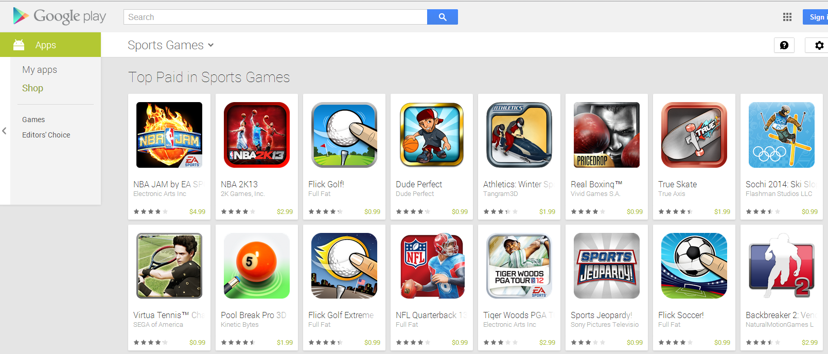

1. As discussed in class: if two models have very similar R2 values, the **simpler** model is often the better choice. However, if you feel the more complicated model contains an important effect that the simple model doesn’t allow (e.g., effect of competition), you might want retain the more complicated model.